**Artificial Neural Network**

The term "Artificial neural network" refers to a biologically inspired sub-field of artificial intelligence modeled after the brain. An Artificial neural network is usually a computational network based on biological neural networks that construct the structure of the human brain. Similar to a human brain has neurons interconnected to each other, artificial neural networks also have neurons that are linked to each other in various layers of the networks. These neurons are known as nodes.

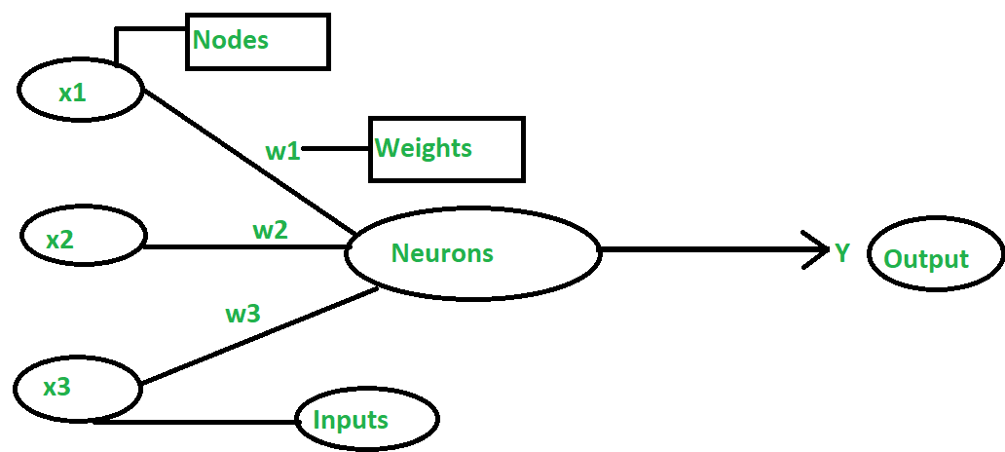

An Artificial Neural Network in the field of Artificial intelligence where it attempts to mimic the network of neurons makes up a human brain so that computers will have an option to understand things and make decisions in a human-like manner. The artificial neural network is designed by programming computers to behave simply like interconnected brain cells.

There are around 1000 billion neurons in the human brain. Each neuron has an association point somewhere in the range of 1,000 and 100,000. In the human brain, data is stored in such a manner as to be distributed, and we can extract more than one piece of this data when necessary from our memory parallelly. We can say that the human brain is made up of incredibly amazing parallel processors.

**Example:** a digital logic gate that takes an input and gives an output. "OR" gate, which takes two inputs. If one or both the inputs are "On," then we get "On" in output. If both the inputs are "Off," then we get "Off" in output. Here the output depends upon input. Our brain does not perform the same task. The outputs to inputs relationship keep changing because of the neurons in our brain, which are "learning."

## **The architecture of an artificial neural network:**

Artificial Neural Network primarily consists of three layers:

1. **Input Layer:** As the name suggests, it accepts inputs in several different formats provided by the programmer.
2. **Hidden Layer:** The hidden layer presents in-between input and output layers. It performs all the calculations to find hidden features and patterns.
3. **Output Layer:** The input goes through a series of transformations using the hidden layer, which finally results in output that is conveyed using this layer.

The artificial neural network takes input and computes the weighted sum of the inputs and includes a bias. This computation is represented in the form of a transfer function

What is Artificial Neural Network

It determines weighted total is passed as an input to an activation function to produce the output. Activation functions choose whether a node should fire or not. Only those who are fired make it to the output layer. There are distinctive activation functions available that can be applied upon the sort of task we are performing.

The ANN learns through various learning algorithms that are described as supervised or unsupervised learning.

* In supervised learning algorithms, the target values are labeled. Its goal is to try to reduce the error between the desired output (target) and the actual output for optimization. Here, a supervisor is present.
* In unsupervised learning algorithms, the target values are not labeled and the network learns by itself by identifying the patterns through repeated trials and experiments.

**ANN Terminology:**

* **Weights:**each neuron is linked to the other neurons through connection links that carry weight. The weight has information and data about the input signal. The output depends solely on the weights and input signal. The weights can be presented in a matrix form that is known as the Connection matrix.
* **Bias:** Bias is a constant that is added to the product of inputs and weights to calculate the product. It is used to shift the result to the positive or negative side. The net input weight is increased by a positive bias while The net input weight is decreased by a negative bias.
* **Threshold:** A threshold value is a constant value that is compared to the net input to get the output. The activation function is defined based on the threshold value to calculate the output.
* **Learning Rate:** The learning rate is denoted α. It ranges from 0 to 1. It is used for balancing weights during the learning of ANN.
* **Target value:**Target values are Correct values of the output variable and are also known as just targets.
* **Error:**It is the inaccuracy of predicted output values compared to Target Values.

## **How do artificial neural networks work?**

Artificial Neural Network can be best represented as a weighted directed graph, where the artificial neurons form the nodes. The association between the neurons outputs and neuron inputs can be viewed as the directed edges with weights. The Artificial Neural Network receives the input signal from the external source in the form of a pattern and image in the form of a vector. These inputs are then mathematically assigned by the notations x(n) for every n number of inputs.

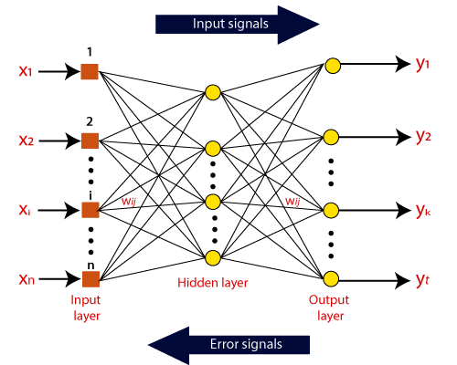

Afterward, each of the input is multiplied by its corresponding weights ( these weights are the details utilized by the artificial neural networks to solve a specific problem ). In general terms, these weights normally represent the strength of the interconnection between neurons inside the artificial neural network. All the weighted inputs are summarized inside the computing unit.

If the weighted sum is equal to zero, then bias is added to make the output non-zero or something else to scale up to the system's response. Bias has the same input, and weight equals to 1. Here the total of weighted inputs can be in the range of 0 to positive infinity. Here, to keep the response in the limits of the desired value, a certain maximum value is benchmarked, and the total of weighted inputs is passed through the activation function.

The activation function refers to the set of transfer functions used to achieve the desired output. There is a different kind of the activation function, but primarily either linear or non-linear sets of functions. Some of the commonly used sets of activation functions are the Binary, linear, and Tan hyperbolic sigmoidal activation functions.

**Supervised Learning Algorithms:**

* **Delta Learning:**It reduces the error over the entire learning and training process. In order to minimize error, it follows the gradient descent method in which the Activation Function continues forever.
* **Outstar Learning:**  we use the concept that a Neural Network is arranged in layers, and weights connected through a particular node should be equal to the desired output resulting in neurons that are connected with those weights.

**Unsupervised Learning Algorithms:**

* **Hebbian Learning:**It was proposed by Hebb in 1949 to improve the weights of nodes in a network. The change in weight is based on input, output, and learning rate. the transpose of the output is needed for weight adjustment.
* **Competitive Learning:** It is a winner takes all strategy. Here, when an input pattern is sent to the network, all the neurons in the layer compete with each other to represent the input pattern, the winner gets the output as 1 and all the others 0, and only the winning neurons have weight adjustments.

## **Advantages of Artificial Neural Network (ANN)**

**Parallel processing capability:**

Artificial neural networks have a numerical value that can perform more than one task simultaneously.

**Storing data on the entire network:**

Data that is used in traditional programming is stored on the whole network, not on a database. The disappearance of a couple of pieces of data in one place doesn't prevent the network from working.

**Capability to work with incomplete knowledge:**

After ANN training, the information may produce output even with inadequate data. The loss of performance here relies upon the significance of missing data.

**Having a memory distribution:**

For ANN is to be able to adapt, it is important to determine the examples and to encourage the network according to the desired output by demonstrating these examples to the network. The succession of the network is directly proportional to the chosen instances, and if the event can't appear to the network in all its aspects, it can produce false output.

**Having fault tolerance:**

Extortion of one or more cells of ANN does not prohibit it from generating output, and this feature makes the network fault-tolerance.